Swinburne University of Technology


COS30049

Computing Technology Innovation Project

Assignment 3
Full-Stack Web Development for AI Applications in Cybersecurity Scenario

Author : Truong Ngoc Gia Hieu
Duong Nguyen Dang
Pham Dinh Duc Anh
Pahan Pathirathna
Lecturer: Mr. Hoang (Author) Nguyen
Due Date: ${\text{12}}^{\text{t}\text{h}}$ April, 2026
Submission Date: ${\text{12}}^{\text{t}\text{h}}$ April, 2026
Word Count:
Table of Contents
Part A: Abstraction
1.1 Assignment Requirements
1.2 Project Overview
1.3 Scope of the Project
1.4 Executive Summary
Part B: Backend Integration
2.1 Overall Architecture and Framework Selection
2.2 Model Serialization and Loading
2.3 API Endpoint Design
2.4 Data Processing Workflow
2.5 Error Handling and Validation

Part A: Abstraction

1.1 Assignment Requirements
In the third assignment of COS30049, the team is tasked to design and implement a complete full-stack web application integrated with machine learning models to solve a real-world problem. Furthermore, the project focuses on applying advanced algorithms, system design principles, and software development techniques to build a functional system for end-users, ensuring that all components are linked together seamlessly and professionally justified.

1.2 Project Overview
During participating in the COS30049 unit, our team has developed an integrated security platform that utilizes machine learning models to detect and mitigate digital threats. In detail, the system serves as a 'smart filter' capable of analyzing three major categories: Fake News (URLs), Spam & Ham Emails, and Malware Detection. By processing user-provided inputs, the application delivers real-time risk assessments and probability distributions, transforming complex AI predictions into actionable insights for end-users.
Furthermore, the primary goal of this project is to deliver a fully functional web ecosystem that provides high-accuracy threat detection. Therefore, we expect the innovative platform to not only identify malicious content but also to visualize data through interactive metrics such as confidence scores and probability charts. Ultimately, the project will result in a professional-grade platform supported by comprehensive technical documentation and a scalable system design
Next, the journey throughout the COS30049 unit demonstrates a significant progression in technical complexity and system design:
- Assignment 1 (Project Proposal and Planning): In the initial phase, our team focused on defining the project scope and identifying a real-world problem. Besides, we established a project roadmap, conducted feasibility studies for our AI solutions, and designed the preliminary system architecture to ensure a solid foundation.
- Assignment 2 (Data Processing and Model Evaluation): In the second assignment, we shifted to the core intelligence of the platform and performed extensive data cleaning and preprocessing on real-world datasets and conducted rigorous model evaluations. By analyzing metrics such as accuracy, precision, and recall, we selected the most effective Machine Learning models for threat detection.
- Assignment 3 (Full-stack Integration and Implementation): In this final phase, we are architecting a complete full-stack application. Additionally, the primary goal is to link together our evaluated AI models with a robust FastAPI backend and an interactive web frontend, transforming our analytical research into a functional security platform for end-users.

1.3 Scope of the Project
Then, the scope of this fascinating project concentrates on developing a unified security ecosystem, structured into three primary components:
- Core Intelligence: In the application, we implement three specialized Machine Learning models: Multinomial Naive Bayes for Spam & Ham detection, and Random Forest for Fake News (URLs) and Malware classification. These models are designed to deliver high-accuracy probability distributions, providing users with precise risk assessments for each digital threat.
- System Integration: The project involves building a robust full-stack architecture that integrates a FastAPI backend for high-performance model inference with a modern web frontend developed using Vue.js (and Tailwind CSS for styling). As a result, this seamless connection ensures real-time communication between the AI engines and the user interface, providing a responsive and intuitive experience
- Functional Deliverables: The platform allows users to input raw data (URLs or text) and receive real-time risk assessments, visualized through intuitive metrics and confidence scores.1.4 Executive Summary

1.4 Executive Summary

Part B: Backend Integration

2.1 Overall Architecture and Framework Selection
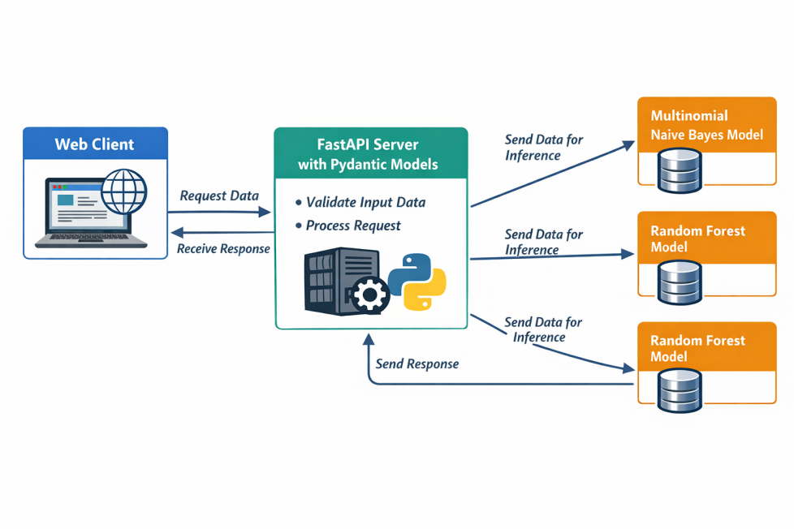

Figure 1: Logical Data Flow and Backend Integration Architecture.
It is clear that the main focus of the architecture is on the smooth flow of information between the client side and the backend intelligence layer. Furthermore, the process is initiated when the Web Client (developed with Vue.js) sends a request to the FastAPI Server. Subsequently, the backend utilizes Pydantic models for rigorous input validation, ensuring data integrity before the data is routed to specialized machine learning engines including Multinomial Naive Bayes and Random Forest for inference. Particularly, the integration process follows a structured pipeline:
- Data Validation & Processing: Upon receiving a request from the Web Client, the FastAPI server utilizes Pydantic to ensure input integrity before performing real-time preprocessing (vectorization).
- Model Inference: The system then routes the processed data to the specific specialized engine—Multinomial Naive Bayes for Spam detection or Random Forest for Fake News and Malware analysis.
- Inference Response: Each model performs a probabilistic prediction, and the result is encapsulated into a JSON response, which is then sent back to the client for immediate visualization."

2.2 Model Serialization and Loading
In the model serialization and loading part, the team ensures that the intelligence engines are portable and ready for production. This process is executed through three concise steps:
- Serialization with Joblib: Our team utilize the Joblib library to serialize the trained Multinomial Naive Bayes and Random Forest models into binary .pkl files. As a result, this approach allows the system to store the exact weights and decision logic obtained from the training phase.
- Vectorizer Preservation: Alongside the models, the TfidfVectorizer is also serialized which is crucial to ensure that the numerical mapping of input data remains consistent between the training and inference stages, preventing feature mismatch.
- Startup Loading Mechanism: For minimizing latency, all .pkl artifacts are loaded into the system memory during the FastAPI startup event. By residing in RAM, the models can provide near-instantaneous predictions for every user request without repetitive I/O operations

2.3 API Endpoint Design
Regarding of facilitating communication between the Vue.js frontend and the AI models, my team designed a centralized RESTful endpoint using FastAPI. As a result, we believe that design ensures that all user inputs whether URLs, emails, or code snippets are processed through a single, secure gateway.
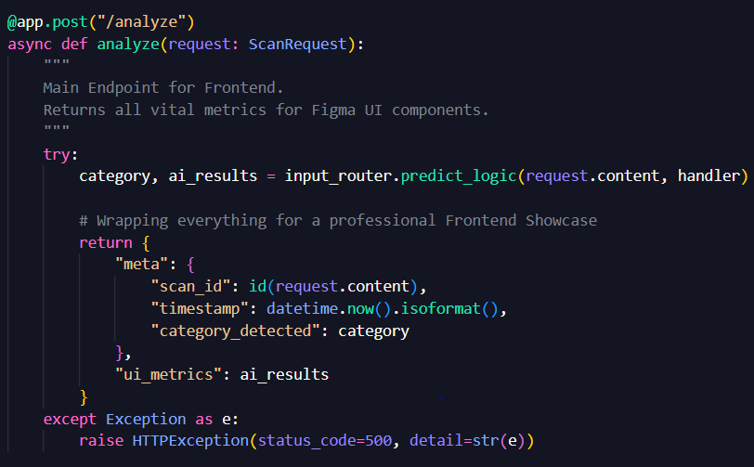
Figure 2: FastAPI Endpoint Implementation for Centralized Request Routing and Pydantic Data Validation.
As indicated in Figure 2, it displays the actual implementation of the /analyze endpoint within the FastAPI framework. Additionally, it showcases the use of a ScanRequest class inherited from Pydantic to enforce strict data types for incoming user content. Besides, the code also shows a modular approach, with the input_router acting as a layer that makes decisions by choosing the right machine learning handler based on the input's characteristics. Finally, the function encapsulates the results into a standardized JSON response, providing organized metadata and UI-ready metrics for the frontend.

2.4 Data Processing Workflow

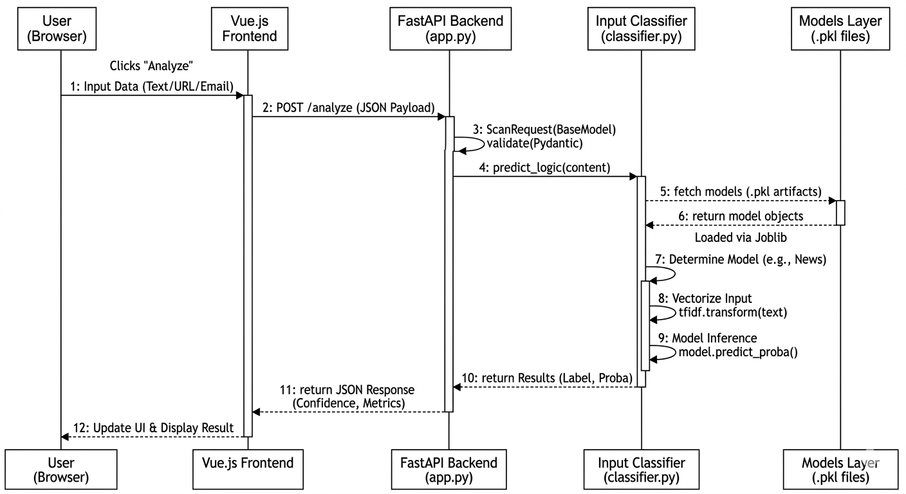
Figure 3: Sequence Diagram of the Integrated Data Processing Workflow

Subsequently, Figure 3 highlights integrated data processing workflow, showcasing the sequential interactions between the system's components over a single request. Specifically, the diagram demonstrates a highly structured and stateless communication pattern including:
- Step 1 (Transmission): The Vue.js Frontend sends a POST request with a JSON payload to the /analyze endpoint in app.py.
- Step 2 (Validation): The FastAPI Backend triggers Pydantic (ScanRequest) to validate the input structure, ensuring data integrity before processing.
- Step 3 (Routing): The Input Classifier (classifier.py) analyzes the raw string (Regex for URLs, Keywords for Malware) to dynamically route the request to the correct AI logic.
- Step 4 (Inference): The Models Handler performs text vectorization and executes the prediction using pre-loaded .pkl models (predict_proba).
- Step 5 (Response): The system returns a comprehensive JSON response (Labels, Confidence, Risk Scores) to the Frontend for immediate UI update.

2.5 Error Handling and Validation
Finally, this section outlines the mechanisms ensuring system stability and data integrity during the integration process:
- Schema Validation: The backend utilizes Pydantic (ScanRequest) to enforce strict data types. Any request lacking the "content" field is automatically rejected with a 422 Unprocessable Entity error before reaching the AI logic.
- Input Sanitization: Within classifier.py, the predict_logic function applies .strip() and Regex matching to handle empty strings or malformed URLs, ensuring that only valid data is routed to the inference engines.
- Global Exception Handling: The main /analyze route is wrapped in a Try-Except block. This catches runtime anomalies (e.g., model loading issues) and returns a structured 500 Internal Server Error, preventing backend crashes while providing clear feedback.
In summary, the integration of the backend infrastructure successfully transitions theoretical AI models into a functional web service. Therefore, we believe that the system delivers a responsive and reliable security analysis tool by combining FastAPI’s high-performance routing with Joblib’s efficient serialization,. Notably, the implementation of a centralized, validated API ensures that the platform is production-ready, providing real-time intelligence with optimized latency for the final user interface.

